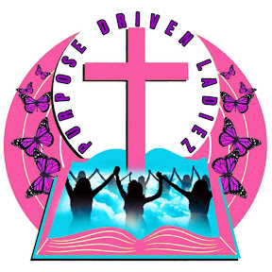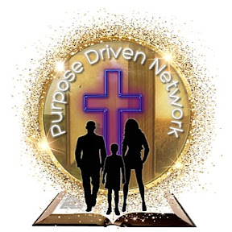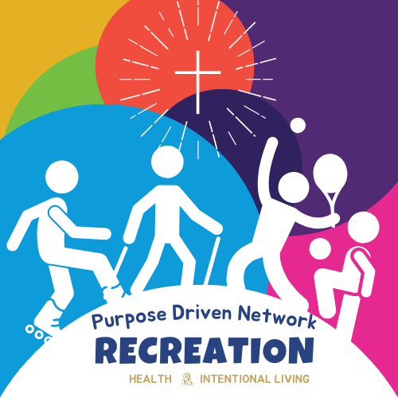

PDN MEMBERSHIP AGREEMENT
This Membership Agreement (the “Agreement”) is entered into as of the date of sign-up (the “Effective Date”) by and between The Purpose Driven Network, hereinafter referred to as “PDN,” and the undersigned individual, hereinafter referred to as the “Member.”

PURPOSE OF MEMBERSHIP
PDN is a lifestyle brand and transformational community designed to inspire, heal, empower and elevate individuals and families through purpose centered living.
Membership is a privilege that grants access to exclusive programs, resources, events and supportive networks that cultivate spiritual, emotional and personal growth.
This agreement outlines the terms and conditions that govern the member’s participation in PDN and its affiliated initiatives.

MEMBERSHIP BENEFITS
Upon acceptance into the PDN Membership, the Member shall receive access to the following benefits:
- Monthly Experiences & Gatherings: Access to PDN events such as Purpose Connect, Healing Circles, Purpose Huddles, workshops, worship nights, retreats, and seasonal initiatives designed to strengthen identity, healing and purpose.

- Digital + Community Support: Access to online resources including devotionals, worksheets, PDN Academy content, purpose tools, prayer support, and community check-ins.

- Purpose Spaces & Amenities: Members may receive access (virtual or in-person) to PDN purpose spaces, wellness-based environments depending on tier and availability.

- Discounts + Exclusive Offers: Special pricing on PDN events, merchandise, programs, coaching, courses and services, along with discounts from approved PDN partners and collaborators.

- Business + Purpose Directory: For members who are business owners or service providers, optional listing within the PDN Member Directory for visibility and collaboration opportunities.

- Priority Access: Early registration for events, programs, trainings, and limited-capacity experiences.

- Member-Only Communication: Access to PDN Members Channel for updates, opportunities, leadership announcements, prayer, accountability and community engagement.

Note: PDN reserves the right to modify the scope of benefits at any time, with prior notice to Members.

MEMBERSHIP FEES
Membership fees correspond to the Member’s selected tier within the Purpose Driven Network (PDN). All paid memberships are billed in advance and grant access to the benefits associated with each tier.

- Founding MOMs Circle Rate: $125/month (discounted from $140/month), billed in advance.

- Billing Cycle: Payments are due on the 1st of each month and cover the upcoming month’s membership period. Example: A payment made on or before March 1st covers membership from March 1–31. Members enrolling mid-month will receive prorated access beginning the day payment is received.

- Payment Methods: PDN accepts the following methods of payment: forms Credit or debit card, Automatic recurring payments via the PDN website, Zelle or ACH (where applicable), All payments must be successfully processed for membership benefits to remain active.

- Failed Payments: If a payment fails or is declined: The Member will receive notice of the failed transaction. A 3-day grace period will be provided to update payment information. The membership may be suspended until the account is brought current.

Membership fees are non-refundable once processed for the current billing period.

TERM AND TERMINATION
- Effective Date: This Agreement becomes effective upon the date of the subscribed membership plan and continues on a month-to-month basis.

- Termination by Member: Members may cancel by providing 30 days' written notice via email to info.purp0sedrivennetwork@gmail.com

- Termination by PDN: PDN may terminate membership at any time due to violations of this Agreement, including failure to pay fees or inappropriate behavior.

- Refund Policy: No refunds will be issued for partial months or unused services after cancellation.

MEMBER OBLIGATIONS & CONDUCT
The Member agrees to:
- Contribute to and promote a respectful and inclusive environment.

- Refrain from illegal, harmful, or disruptive behavior on premises or at PDN-sponsored events.

- Keep contact and billing information current.

PDN RESPONSIBILITIES
PDN agrees to:
- Provide Members with the services and benefits outlined in the membership plan.

- Maintain a clean, safe, and welcoming environment.

- Organize and host events, workshops, and programs aligned with the organization’s mission.

LIABILITY & INDEMNITY
The Member agrees to:
- Waive any liability claims against PDN, its officers, agents, employees, and affiliates for injuries, losses, or damage to personal property while participating in events.

- Indemnify and hold PDN harmless from any claims, damages, or expenses arising from participation in PDN activities or use of facilities.

MEDIA RELEASE
By signing this Agreement, the Member grants PDN permission to photograph, film, or record them during events or at the Clubhouse for promotional and marketing use.
● If a member prefers not to be photographed or recorded, they must notify PDN in writing in advance at info.purp0sedrivennetwork@gmail.com

RESOURCE DIRECTORY (FOR BUSINESS MEMBERS)
Eligible business-owner Members may request inclusion in the PDN Resource Directory.
- Inclusion is subject to verification and approval by PDN.

- Members must provide accurate, up-to-date business information (e.g., business name, website, logo, service description).

CONFIDENTIALITY
The Member agrees to maintain confidentiality regarding personal and business information shared within the PDN or during PDN events, unless express consent is provided for disclosure.

GOVERNING LAW
This Agreement shall be governed by the laws of the State of New York. Any legal disputes shall be resolved in the courts of New York County, New York.

ENTIRE AGREEMENT
This Agreement constitutes the full and complete understanding between the parties and supersedes all prior agreements, written or oral. Any amendments must be in writing and signed by both parties.

SIGNATURES
By signing below, the Member confirms that they have read, understood, and agree to the terms outlined in this Agreement.
Member Name: ______________________________________
Signature: __________________________________________ Date:__________________________
PDN Representative: ____________________________
Signature: __________________________________________
Date: __________________________

Final Notes:
- This Agreement also functions as part of the mutual code of conduct between PDN and the Member.

- Membership structure and terms may be updated at PDN’s discretion, with prior notification to Members.

